NLP Lab Session Week 9
More on Features and Evaluation for Classification
Part 3: The Evaluation Method of Cross-Validation

Continuing our session with the movie review sentences

Cross-Validation

As a final topic in evaluation, we have discussed that our testing of the features on the movie reviews and movie review sentences data is often skewed by the random sample. The remedy for this is to use different chunks of the data as the test set to repeatedly train a model and then average our performance over those models.

This method is called cross-validation, or sometimes k-fold cross-validation. In this method, we choose a number of folds, k, which is usually a small number like 5 or 10. We first randomly partition the development data into k subsets, each approximately equal in size. Then we train the classifier k times, where, at each iteration, we use each subset in turn as the test set and the others as a training set.

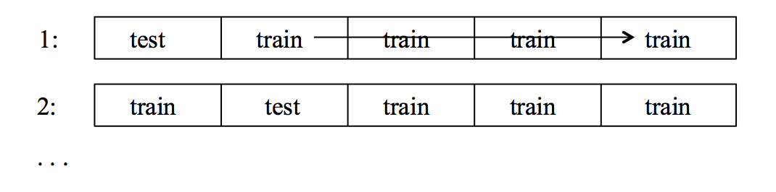
NLTK does not have a built-in function for cross-validation, but we can program the process in a function that takes the number of folds and the feature sets, and iterates over training and testing a classifier. This function only reports accuracy for each fold and for the overall average.

def cross_validation(num_folds, featuresets):
subset_size = len(featuresets)/num_folds
accuracy_list = []
# iterate over the folds
for i in range(num_folds):
test_this_round = featuresets[i*subset_size:][:subset_size]
train_this_round = featuresets[:i*subset_size]+featuresets[(i+1)*subset_size:]
# train using train_this_round
classifier = nltk.NaiveBayesClassifier.train(train_this_round)
# evaluate against test_this_round and save accuracy
accuracy_this_round = nltk.classify.accuracy(classifier, test_this_round)
print i, accuracy_this_round
accuracy_list.append(accuracy_this_round)
# find mean accuracy over all rounds
print 'mean accuracy', sum(accuracy_list) / num_folds

Run the cross-validation on our word feature sets with 10 folds.
cross_validation(10, featuresets)

Instead of accuracy, we should have a cross-validation function to report precision and recall for each label.

